



# Web Development Project

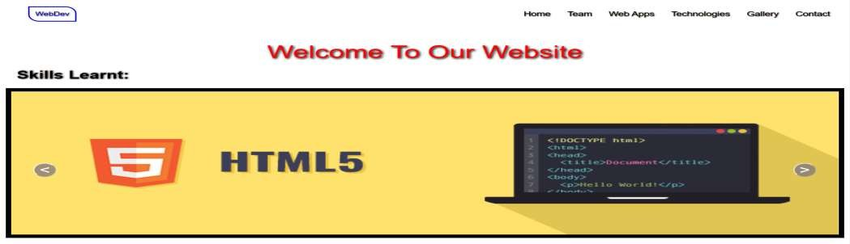<https://anikateagrawal.github.io/WebBootcamp1.0-main/pages/Project.html>

### Languages



🠶 **HTML**-> The Hypertext markup language which is used for creating web pages and web applications.

🠶 **CSS**-> Cascading Style Sheets is a style sheet language which is used to describe the look and formatting of a document written in markup language.

🠶 **JavaScript**-> JavaScript is a scripting language used to create and control dynamic website content, i.e. anything that moves, refreshes, or otherwise changes on your screen without requiring you to manually reload a web page.

🠶 **Bootstrap**-> a collection of HTML, CSS, and JavaScript tools for creating and building web pages and web applications. It is a free and open source project

**Team Members**



|  |  |
| --- | --- |
|  |  |
| 🠶 **Anikate Agrawal** | **201500088** |
| 🠶 **Aastha Goyal** | **201500004** |
| 🠶 **Gursha Agrawal** | **201500259** |
| 🠶 **Disha Agrawal** | **201500225** |
|  |  |
|  |  |
|  |  |
|  |  |
|  |  |
|  |  |
|  |  |



# Web Apps



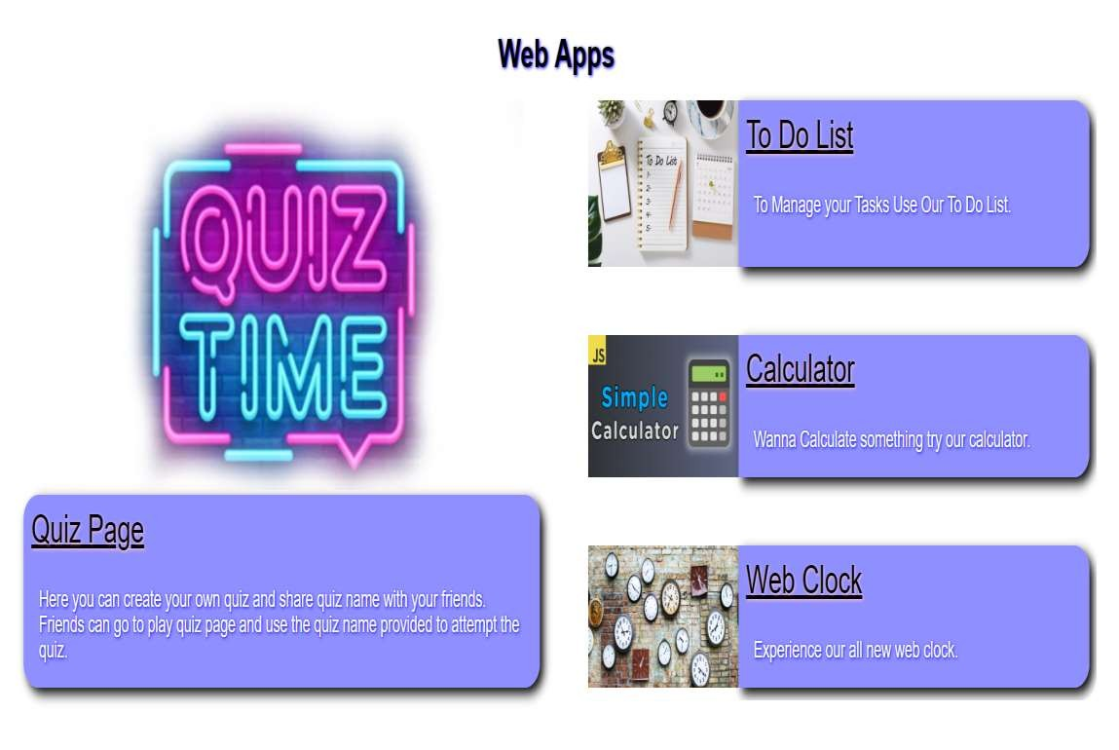

## Quiz Page



Here you can create your own quiz and share quiz name with your friends

Live Link->https://anikateagrawal.github.io/WebBootcamp1.0-main/quizapp/index.html

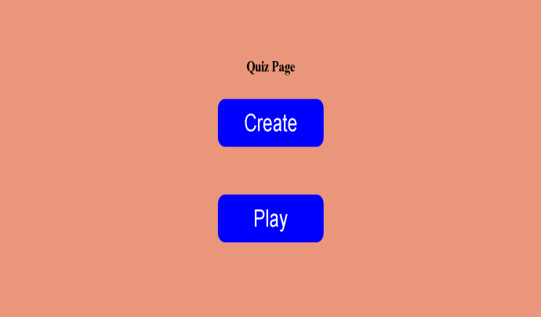



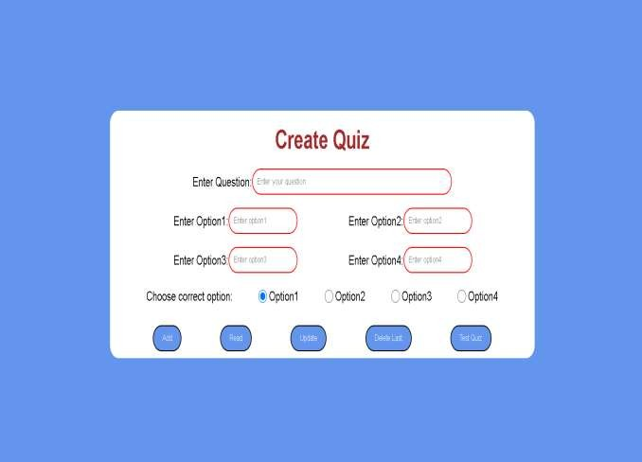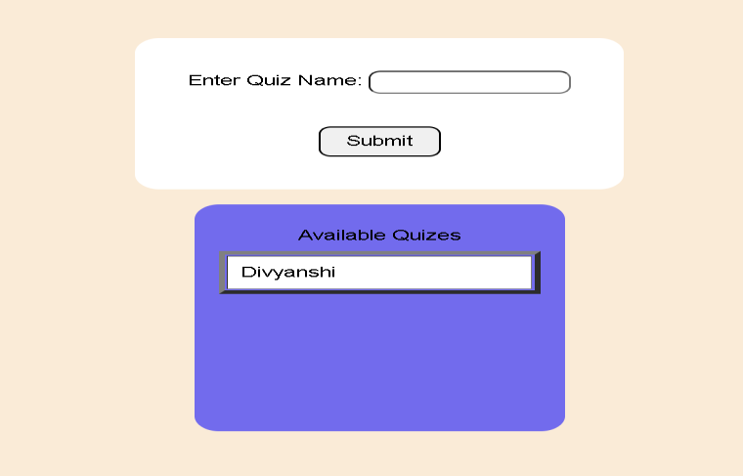

## To-Do List



By Using To-Do list you can manage your Tasks easily

Live Link->https://anikateagrawal.github.io/WevDev-Project/Anikate%20Agrawal2/TO-DO%20LIST/index.html

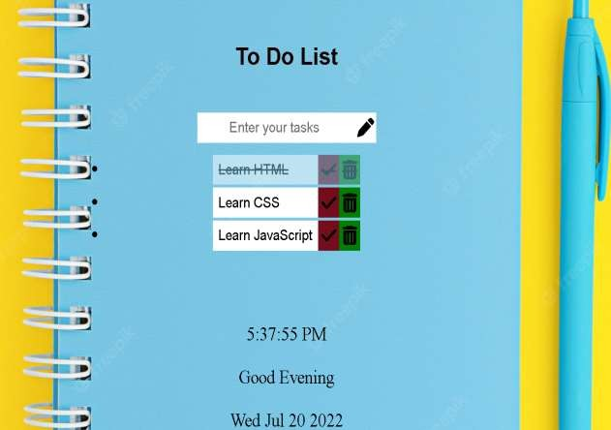

## Calculator



You can easily get the answers of the complex problems in just few seconds.

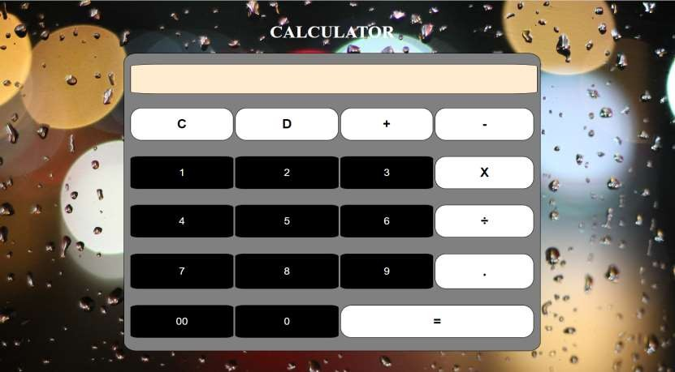

### Web Clock



Here you get to know the live time



## Stop Watch



Wanna Stop Time? Use our Stop Watch

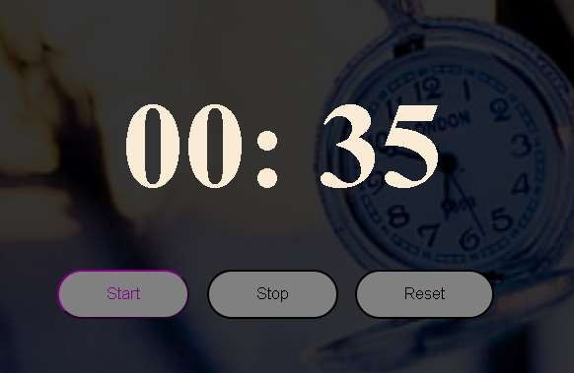

# Web Tech



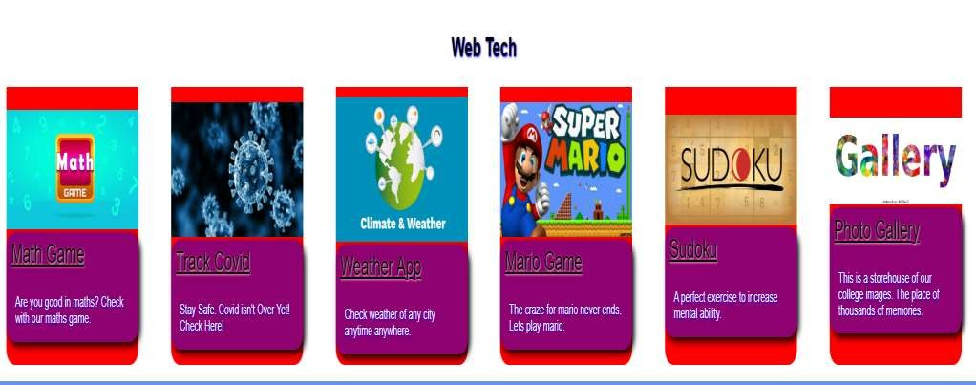

### Math Game



Here you can check how good you are in Maths without getting bored.

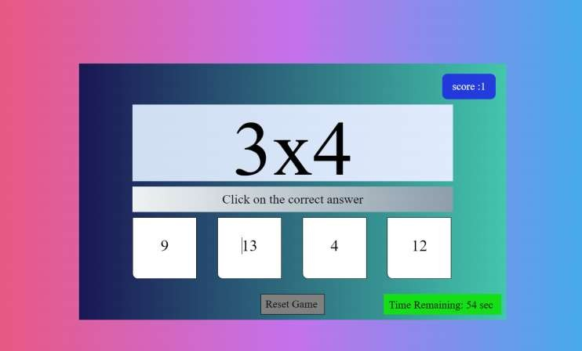

### Track Covid



Here you can find out no. of cases and deaths of covid of any Location.

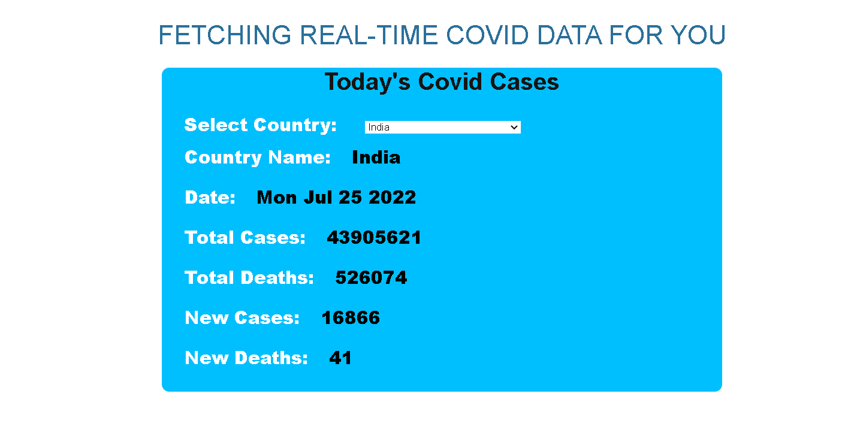

### Weather App



Here You can Find out the climate of any place.

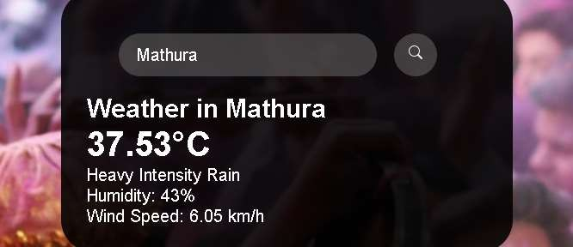

**Mario Game**



Here your childhood favourite game

[Live Link->https://anikateagrawal.github.io/WebBootcamp1.0- main/Mario-Level-1-master/index.html](https://anikateagrawal.github.io/WebBootcamp1.0-main/Mario-Level-1-master/index.html)



## SudoKu



If you are a sudoku lover then get ready to have fun

Live Link-><https://gurshaagrawal.github.io/sudoku.github.io/>

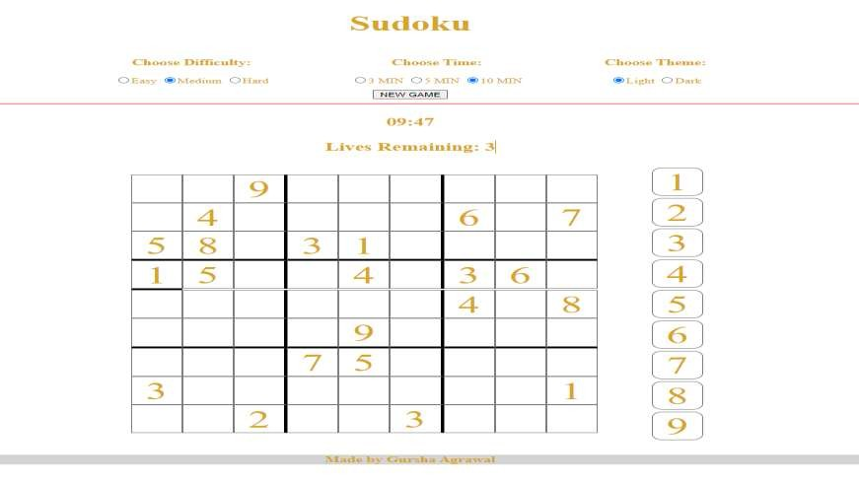

Place of Thousand of memories

## Gallery

Live Link-><https://agrawaldisha.github.io/WebDev/html/flexboxphotogallery.html>





## Music Player



To relieve stress , use our music player.

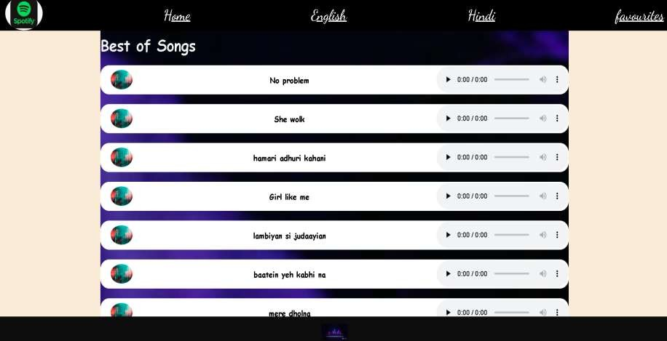

## Convertor



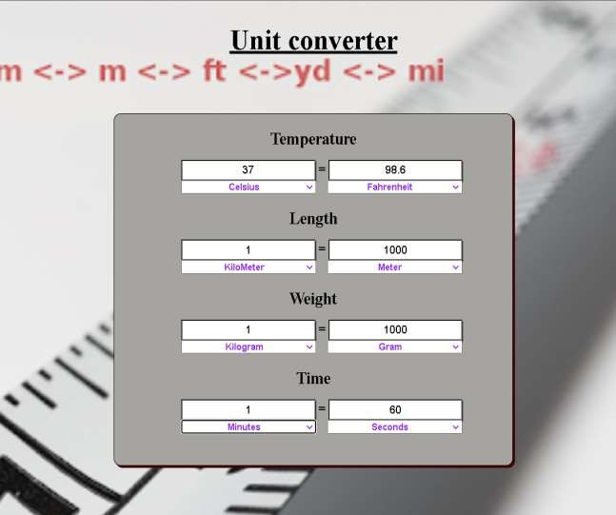Here you can easily do conversion b/w different types of measurement. Live Link-><https://aasthagoyal09.github.io/WebDevelopmentProject/>

**Contact Us**



You can send us a message anytime you want.

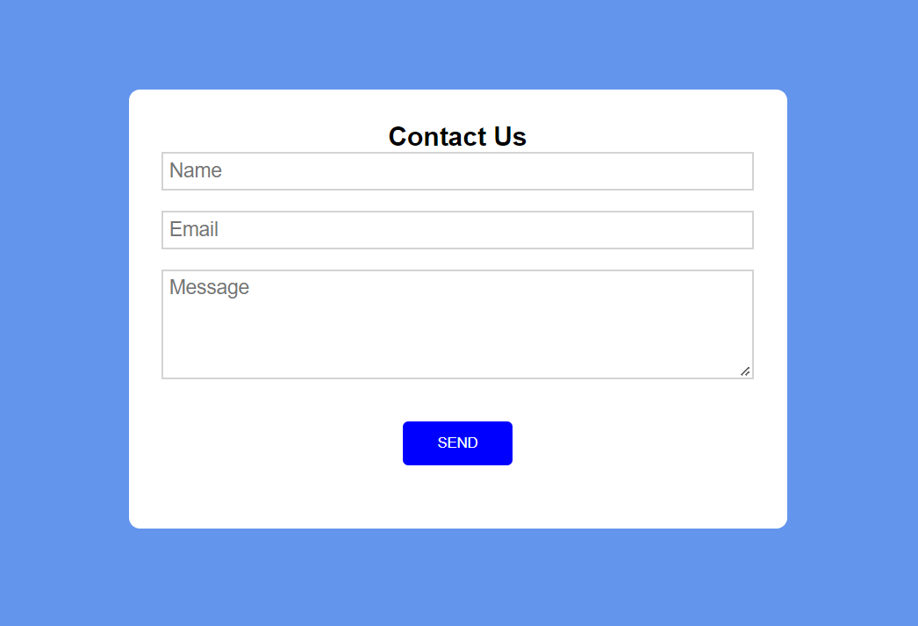



**Thank You**

We are ready to receive your valuable feedback.